**Git Hands-On Lab Documentation**

**Title:**- Version Control with Git – Hands-On Lab

**Objective:-**  
This lab introduces fundamental Git commands and workflows, guiding users through Git configuration, editor integration, and repository management using GitLab.

**Lab Objectives:-**

By the end of this lab, you will be able to:

* Configure Git on your local machine
* Integrate Notepad++ as the default Git editor
* Create and manage a Git repository
* Push code to a remote GitLab repository

**Steps :-**

1. Git Configuration Setup
2. Integrate Notepad++ as Default Git Editor
3. Create and Manage Git Repository
4. Push to GitLab

**Output Snapshots :-**

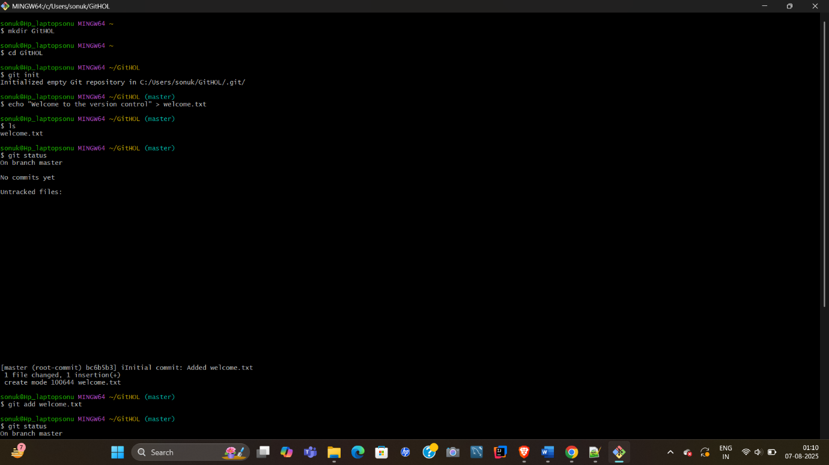

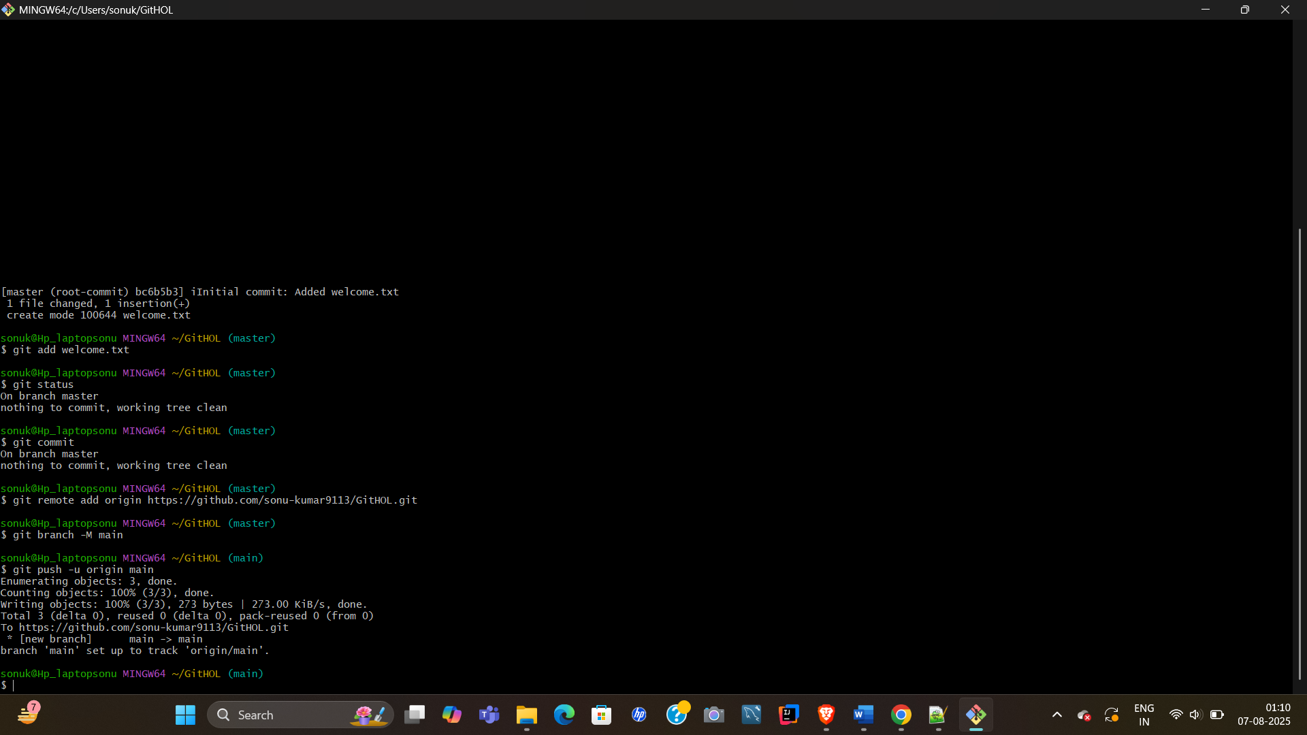

**Result:-**

- Configured Git and set up your identity

- Integrated Notepad++ as your default Git editor

- Created a local Git repository and committed changes

- Pushed your code to a remote GitLab repository